OBJECTS TO USE ALONGSIDE MORNING ACTIVITIES
Your child can explore this to anticipate an event eg washing, dressing, eating, changing

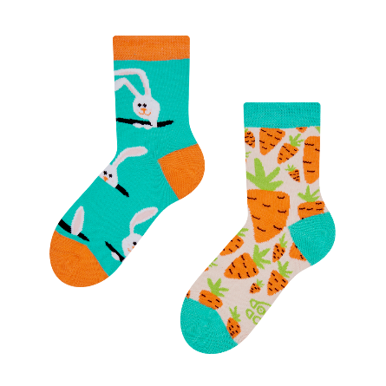
WASHING GETTING DRESSED

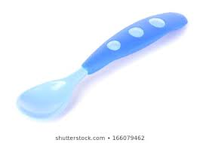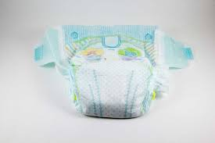

FOOD TIME CHANGING TIME

