EXPLORING AFTERNOON SUBJECTS AND IDEAS
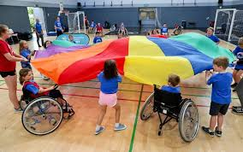
EXPLORING COLOURFUL RAINBOW FABRIC

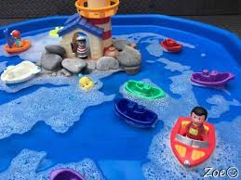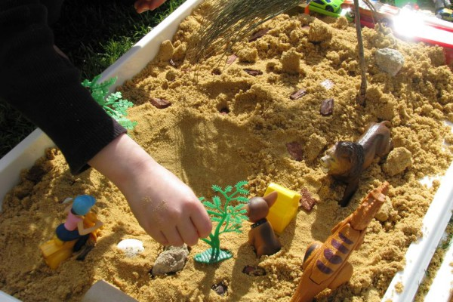
EXPLORING OBJECTS IN WATER EXPLORING OBJECTS IN SAND

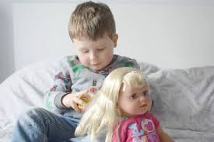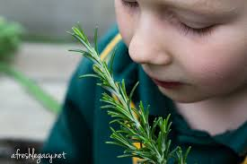
LOOKING AFTER DOLLIES EXPLORING SENSES IN THE GARDEN

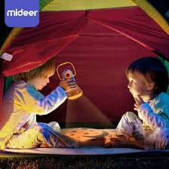
EXPLORING LIGHTS AND TORCHES EXPLORING MUSICAL SOUNDS

(PTO)
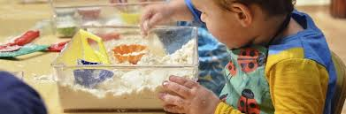
MESSY FOOD PLAY OR COOKING

https://www.youtube.com/watch?v=R6dWH77cgFk
GOODBYE BLUE BEAR SONG
https://www.youtube.com/watch?v=0LDArAJf7-c
GOODBYE CHICKENS SONG

