EXAMPLES OF SENTENCES USING SIMPLE WORDS AND PICTURES
USE THE SIMPLE WORDS FROM THE WORD SHEET ( cut and stick them to make the sentences) AND THEN CUT OUT PICTURES FROM CATALOGUES OR MAGAZINES ETC TO MAKE SIMPLE SENTENCES. THEN ‘READ’ THE SENTENCFES.

I like the .
I like the .

I like the and the 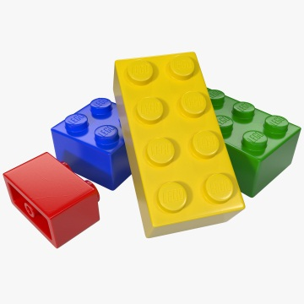 .
and .

and .

