Computing
Summer 1 Week 3 - Using Google Earth
This week we are going to select five areas using Google earth and create a fact-file using Google Earth, Google and any reference books you might have at home.
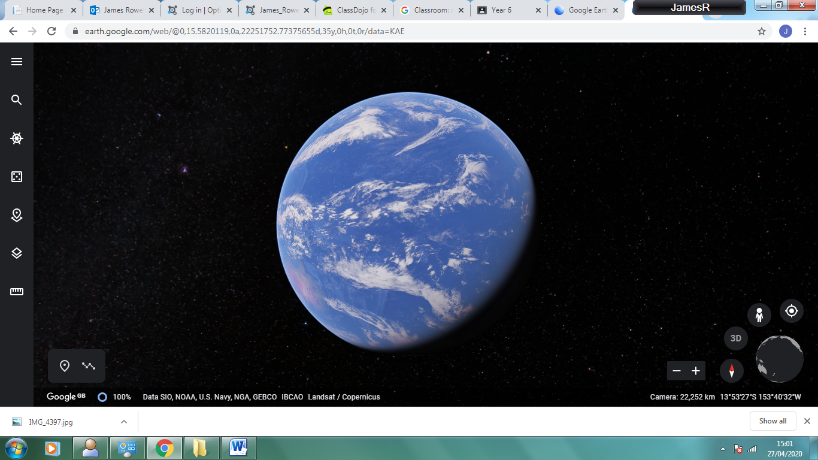

This is roughly what the Google Earth Home screen looks like.
Select the menu icon (The three lines on the top left right).
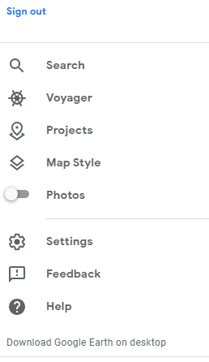
Select Projects.
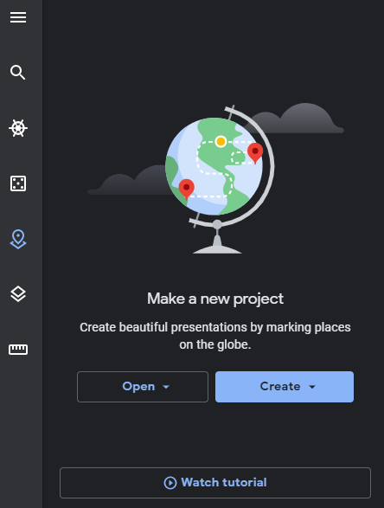
Select watch tutorial and play the video to show you how to make a story on Google Earth. Watch it through a couple of times first. Then make a story that starts in Beckton and travels around the world in some sort of order - if possible. It can be made up a be a real trip you have taken.
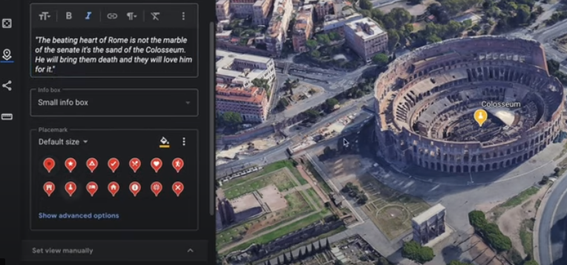
Add your own information into the places you have selected using Google, general knowledge or any reference books you might have at home.
Once you have completed the task and are happy with it, share it with one person in the class. I will share my example with you all later in the day.
Enjoy!
If for any reason, you can’t get Google Earth to run, make your fact file on paper using drawings and writing.

