Numeracy homework
I can estimate and measure how much containers will hold.
To fill | My estimate (guess) |  |  | The actual measurement
To fill | less than  1 litre | more than 1 litre | about 1 litre | The actual measurement
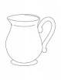 jug
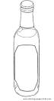bottle
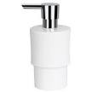
soap container
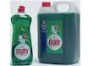
squeezy bottle
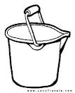bucket
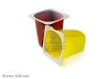
yoghurt pot
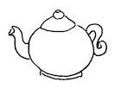teapot
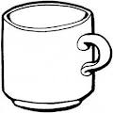mug

Dear Parent / Helper, We have been learning about measuring length and capacity in our numeracy lessons. I hope you don’t get too wet as your child does this homework! Good luck.

