

***LEARNING FROM HOME***

***YEAR 6***  ***– Week Beginning 15.06.20***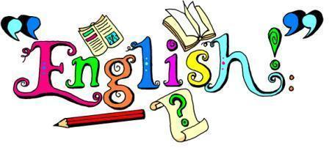

**Reading –** Read the next part of Holes and answer the questions.

**Writing and Grammar** – Use the PowerPoint presentation to see this week’s activities. They’re all centred around a picture from Pobble and there’s a different activity for each day. You’ll apply your learning from previous weeks as well as expanding your vocabulary.

**Spelling** – Log on to Spelling Shed to find the spellings that have been assigned this week. Email uks2@northbeckton.ttlt.academy if you still don’t have your login details.

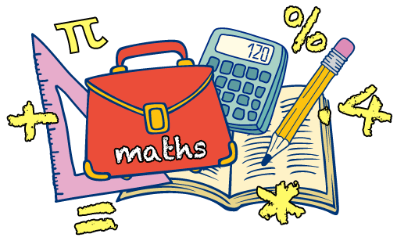

**Maths –** This week we’re recapping our fractions knowledge. There’s an activity for each day with the week covering addition, subtraction, division and multiplication. Each day includes a reasoning problem (or two) to help challenge you further. There’s also a challenge for Friday!

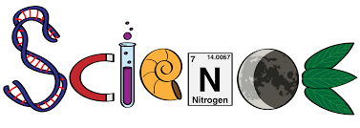

**Animals Including Humans :** This week we’re learning about how we transport nutrients and water around our body. Use the PowerPoint to guide your learning and once you’ve finished, complete the labelling activity. You could even draw the image yourself and label it!



**History:** This week’s history is all about the American Civil War – don’t get confused, yes, it is different to the War of Independence! The war is connected to slavery, so you may want to recap the lesson on that. You are going to research one (or more) of the key figures and then present your research. There’s names of people to research and examples of what it should look like on the PowerPoint.

**Computing**: Continue using code.org to practise your coding skills.

**Art:** Look at Week 3 on the art summer guidance. This week, you’re not only going to be drawing 3D shapes, you’re going to be learning how to shade them effectively too!

**Additional Activities/suggestions:**

Can you make your own flight school?

Have a look at the link attached for more information:

<https://www.goodhousekeeping.com/home/craft-ideas/g3754/how-to-fold-a-paper-airplane/>