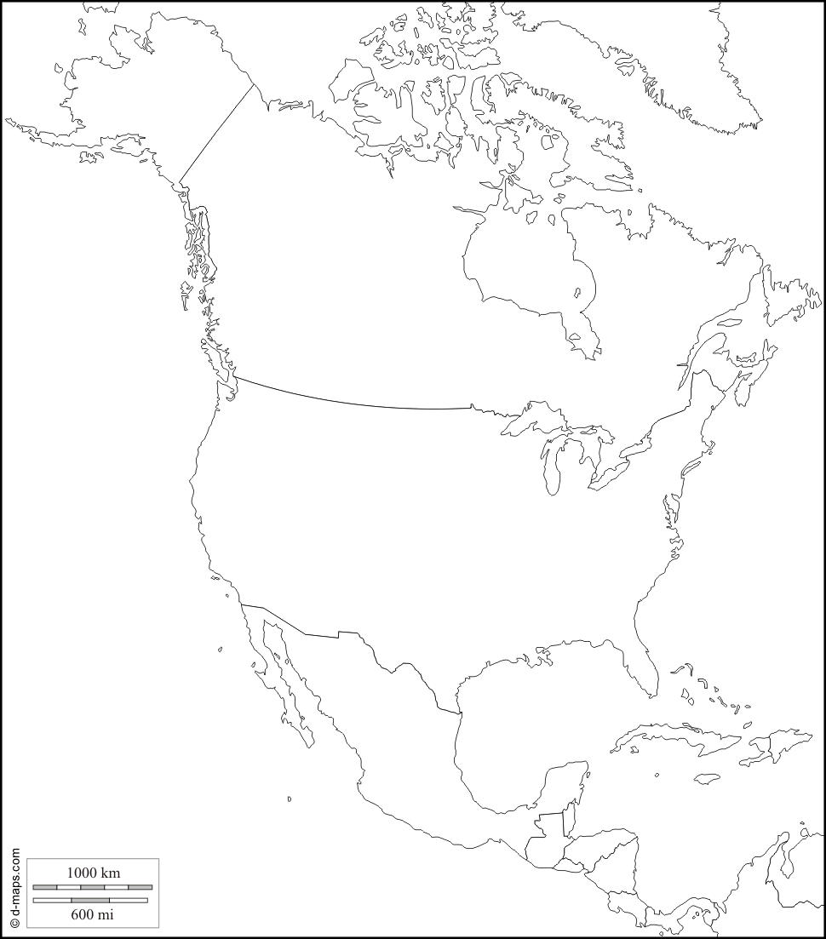
1. Find and label all the countries in North America. Each country should be coloured in a different colour.

2. Find out the names of the 2 neighbouring countries of North America, label them and colour them.

3. Find out the name of the oceans surrounding North America.

