LEARNING FROM HOME
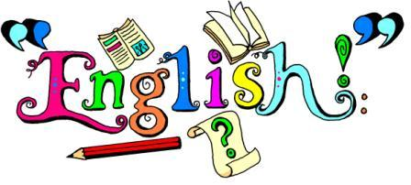
YEAR 4 -Week Beginning 04.05.20
- Using the teacher examples and features list, write a descriptive text using ideas from Oliver Twist. You could describe the workhouse, a character you like or one of the Victorian streets.
- Watch the video below on prepositions and read the PowerPoint on determiners. Complete the main activities on both grammar features. If you want a challenge, complete the challenge questions too!
- https://www.bbc.co.uk/bitesize/topics/zwwp8mn/articles/zw38srd
- Read chapter 4 of Oliver Twist. Answer the questions on the sheet in your home learning book.

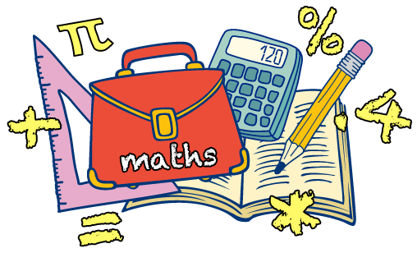
- Read the PowerPoint on volume and capacity, then complete the main activity reading measurements and converting. If you want a challenge, complete the challenge questions.
- Why don’t you experiment with capacity in your home? Fill some different containers with water and estimate their capacity. Will you use millilitres or litres?

Living things and their habitats
- Using the internet, research climate change. You could google the term climate change, global warming, and Greta Thunberg. Create a mind map similar to the teacher example. Include as much information as you can.
Use these videos to get your started.
https://www.bbc.co.uk/teach/class-clips-video/science--geography-ks2-how-climate-change-is-affecting-penguins-and-their-habitats/zb2rkmn
https://www.bing.com/videos/search?q=climate+change+videos+ks2&qs=AS&cvid=5e886a2fd0eb440d9106ac4f2d8a7f9a&cc=GB&setlang=en- GB&elv=AY3!uAY7tbNNZGZ2yiGNjfO0nEehXy6KyOiheYo1DyFZ*eLJ*oDILYw1OMIAZo6KQ6afhPRiTbWjOyldQKdArX8LPPM0QbZ8vge1vVEOfleM&plvar=0&PC=NMTS&ru=%2fsearch%3fq%3dclimate%2bchange%2bvideos%2bks2%26form%3dEDGEAR%26qs%3dAS%26cvid%3d5e886a2fd0eb440d9106ac4f2d8a7f9a%26cc%3dGB%26setlang%3den-GB%26elv%3dAY3%2521uAY7tbNNZGZ2yiGNjfO0nEehXy6KyOiheYo1DyFZ*eLJ*oDILYw1OMIAZo6KQ6afhPRiTbWjOyldQKdArX8LPPM0QbZ8vge1vVEOfleM%26plvar%3d0%26PC%3dNMTS&view=detail&mmscn=vwrc&mid=E6F7E2216FD71A4EB609E6F7E2216FD71A4EB609&FORM=WRVORC

History: Use the information given on Dr. Barnardo and the video to create a fact file on him.
https://www.bbc.co.uk/teach/class-clips-video/history-ks1-ks2-thomas-barnardo/zky7pg8
RE: ‘What makes me the person I am?’ Find out if there are any special objects in your religion/culture/family/home. Draw them and explain why they are special.
Computing: Purple Mash: Click on computing and then onto 2Blog. Write a blog about your time at home over the last few weeks.
ART: Research William Morris online. Explain who he was and how he used patterns in your home learning book.
PE: Go on to YouTube. Type in ‘5-a-day exercise.’ Follow the steps on the video to get your daily exercise in.
Music: Listen to Mamma Mia on YouTube. Do you remember it enough to sing along? Can you teach it to your family? Research ABBA who sang the song and write three points about them in your home learning book.

Additional activities: Make a den/pirate ship/spaceship in the garden/bedroom
It’s VE day on Friday! Why don’t you research VE day using the link. You could even host your own VE day tea party at home. https://www.bbc.co.uk/teach/class-clips-video/history-ks2-ve-day/z7xtmfr

Home Learning in Year 4

Working with your child at home may seem a bit daunting in terms of keeping them occupied and
balancing time out. At school, we find keeping to routines a very helpful way of keeping children
focused and balancing out formal learning time with relaxation. This also applies to keeping fairly
regular bedtimes and getting up times to keep things are ‘normal’ as possible.

This may help you – or you may choose to set your own timetable! There is lots of advice and
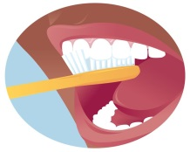 | 7:30-9:00am  Getting ready | Time to get up, washed, have breakfast and get dressed. Talk about the day ahead and ideas for activities.
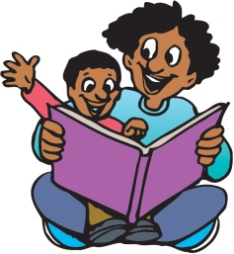 | 9:00am  Reading and Writing | At school we start the day with some reading activities. This could be reading a book / newspaper / magazine / using online resources such as online news.  After this, perhaps you could think about some writing. Could your children write or draw something about the book they read? Could they choose a writing activity in their home learning from school?
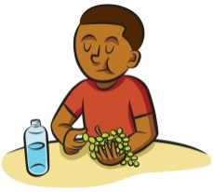 | 10:30am | Time for a break and perhaps a snack. Is there an opportunity for your child to get active? Could they do some jogging / dancing if you are in the house? Is there a possibility to get outside for skipping / jumping / running?
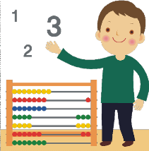 | 11:00am  Maths | There are lots of resources that can be accessed online to help your children get quicker at number facts, and the school will have sent some activities home. Try the BBC website and Times Table Rockstars among others.  Could you do some ‘real life’ maths together such as weighing ingredients for lunch or counting coins out and playing shops?
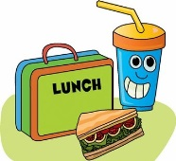 | 12:00  Lunch and playtime | Could your child help to prepare the lunch, clear up and wash up?  For playtime, is there a chance to get active again? Or could your child chose an activity they enjoy such as drawing / colouring…
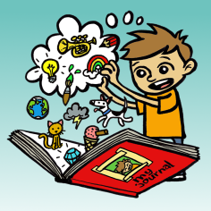 | Afternoon | At school, we tend to do more of the creative subjects in the afternoon. As well as project ideas we have sent home, some other suggestions for ideas at home could be:  -junk modelling something out of old boxes/containers  -researching a famous person and presenting the information they found  -going on a hunt for natural items outside and using to create some art work  -arts and crafts – drawing/colouring/painting/creating  -Science such as freezing / melting, looking at plants and animals in or out of the house
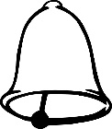 | End of the day | It is important to think about when to end the day and separate home time.
suggestions online if this doesn’t really suit you.

