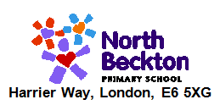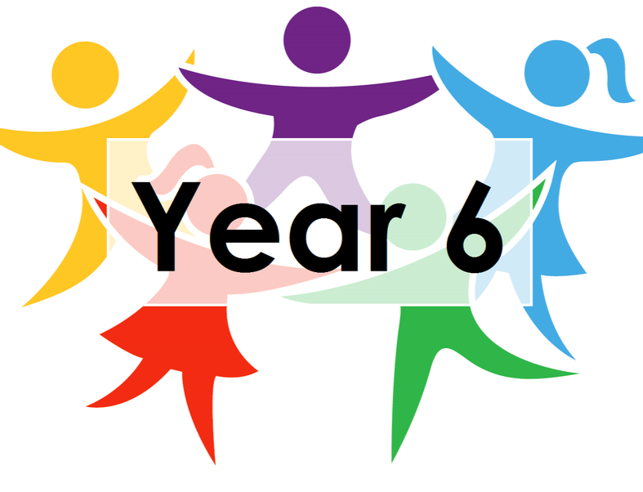

***LEARNING FROM HOME***

***YEAR 6***  ***– Week Beginning 08.06.20***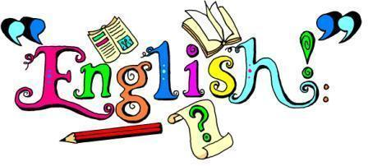

**Reading –** Read the next part of Holes and answer the questions.

**Writing and Grammar** – Use the PowerPoint presentation to see this week’s activities. They’re all centred around a picture from Pobble and there’s a different activity for each day. You’ll apply your learning from previous weeks as well as expanding your vocabulary.

**Spelling** – Log on to Spelling Shed to find the spellings that have been assigned this week. Email uks2@northbeckton.ttlt.academy if you still don’t have your login details.

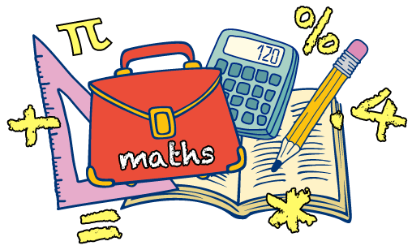

**Maths –** This week we’re recapping our four operations knowledge. There’s an activity for each day with the week covering addition, subtraction, division and multiplication. Each day includes a reasoning problem (or two) to help challenge you further.

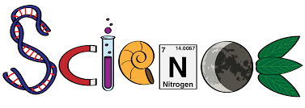

**Animals Including Humans :** Read through the presentation to recap last week’s learning. Then read the information on the circulatory system and answer the reading comprehension questions. Next, pick 3-5 challenge cards and answer the questions on them.



**History:** This week we’re looking at The American War of Independence. It is quite complex and there’s a lot of information, so take your time and break it down into chunks. Once you’ve read the information, pick one of the battles are write your own newspaper report about it.

**Computing**: Continue using code.org to make your own coding games!

**Art:** This week we’re working on drawing basic 3d shapes. Watch the YouTube video and follow the instructions on the Summer 2 Art document <https://www.youtube.com/watch?v=_XJ1A5io8vc>

**Additional Activities/suggestions:**

Create your own mini lid banjo!

Look at the instructions on the website below for more

information.

<https://www.thecrafttrain.com/mini-lid-banjos/>