Date: ___________________________________________
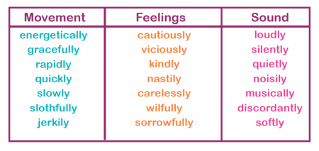
L.O. To use adverbs in a sentence with adjectives, connectives and new punctuation.
_____________________________________________________________________________________________________________________________________________________________________________________________________________________________________________________________________________________________________________________________________________________________________________________________________________________________________________________________________________________________________________________________________________________________________________________________________________
Date: ___________________________________________
L.O. To use adverbs in a sentence with adjectives and connectives.
Match up a verb with an adverb. Make up a sentence containing both words.
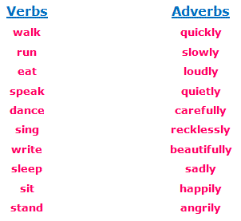

________________________________________________________________________________________________________________________________________________________________________________________________________________________________________________________________________________________________________________________________________________________________________________________
Date: ___________________________________________
L.O. To use adverbs in a sentence with capital letters, finger spaces and full stops.
Adverbs usually end in –ly. Underline the adverbs in the sentences:
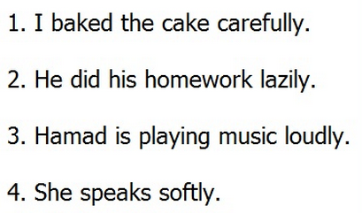

Now use the underlined words in your own sentences.

________________________________________________________________________________________________________________________________________________________________________________________________________________________________________________________________________________________________________________________________________________________________________________________

