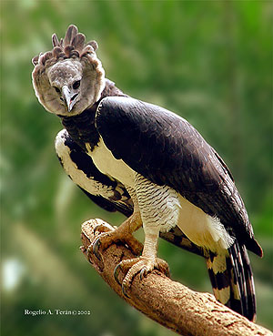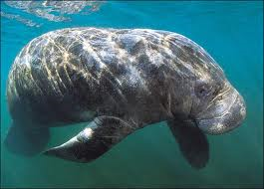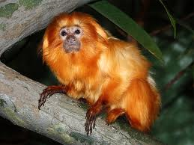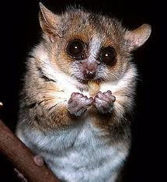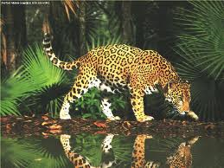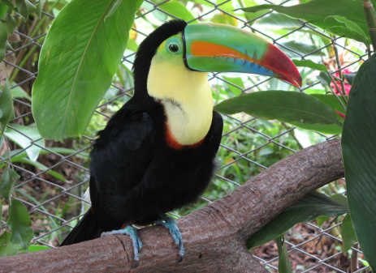  
  
  
  
  
  
  
 **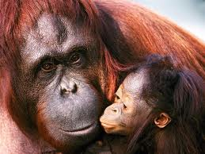  
  
  
  
  
  
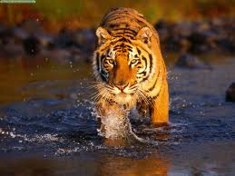  
  
  
  
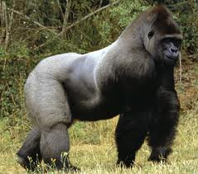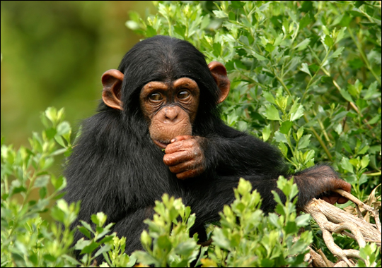**

Last week’s activity was to explore the rainforest and in. particular the different layers. This week we will continue to explore the rainforest and look at the different animals who live there. Below there are different descriptions and photos. Can you match them up to each other? There is also an extra art challenge below if you want to try it at home!

**This is the largest cat in the Americas and is found in Mexico. Hunting is the major cause for it’s population decline.**

**This bird species is a near threatened species and it is endangered mainly because of habitat loss and hunting.**

**This animal is found in the state of Rio de Janeiro. The reason for its population decline is humans hunting for its magnificent fur.**

**These birds are brightly marked and have large, colourful beaks. They are mostly found in Central and South America.**

**This animal is found in the coastlines and rivers of rainforest regions of Africa, Caribbean, Amazon Basin and Florida. There is a probability that about 30 percent of these animals will be extinct in the next three generations.**

**This animal can be found in the forests of Madagascar, where they leap from branch to branch when moving.  
They have short limbs, big eyes, and thin teeth.**

**In the Red Data list, this animal is a critically endangered species. The cause for its declining population is hunting, change in habitat quality and disease-induced mortality.**

**This species is found in the South astern rainforests of Sumatra and Borneo. It has a red colour fur and is critically endangered.**

**This species is found all over the world but despite its widespread abundance, it’s population has declined in the last few decades.**

**This cat appears mostly in India. According to Biologists, poaching and habitat loss are the primary causes for decline in its population.**