MARK MAKING IDEAS USING DIFFERENT MATERIALS

Use hand under hand when doing this exploring
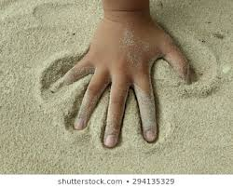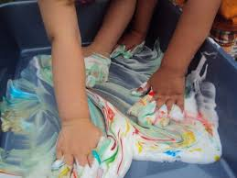

MARK MAKING IN SAND MARK MAKING IN FOAM

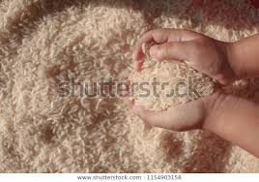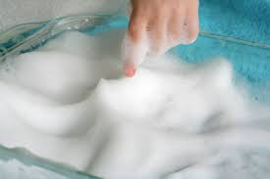

MARK MAKING IN DRY RICE MARK MAKING IN SOAP SUDS/CREAM

