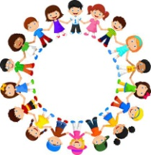

Year 1 & 2
Philosophy for Children

This week, I am going to share a image for you to look at with your child and you could do some more P4C as a family at home. Here are some questions you could ask them:
- What does the picture make you think about? Any first thoughts/ideas/themes (You could share what it made you think about too!) E.g. Change, life, flying, freedom
- Could you think of a question about one of the ideas/themes that the book made you think about? E.g. What would life be like if everyone could fly?
Then you could have a chat about the question you chose together, the one you think you will have lots to talk about together.

Here is your image
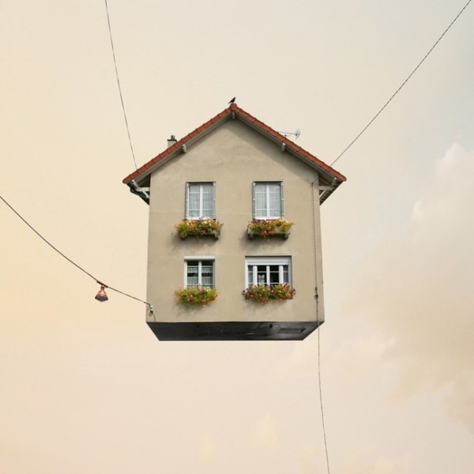
Some big ideas the children may think of (although they may think of lots more): flying, being real, change,
Questions you may want to discuss: Can houses really fly? Can anyone fly if they want to? What would life be like if everything could fly? Would you like to be able to fly? If so why?

