

***LEARNING FROM HOME***

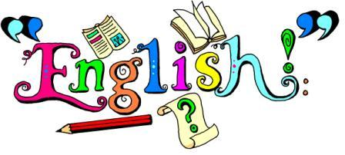 ***YEAR 1 – Week Beginning 4.5.20***

* **Phonics**-Practise reading different words. Remember the steps to help you.

Special friends, Fred talk, Say the word.

There are also sheets in the phonics folder with different phonics activities.

* **English**- Write instructions on how to wash your hands. You can look at the help sheets in the English folder to help you. Remember to use time openers and imperative verbs. You can watch this YouTube video to help you. <https://www.youtube.com/watch?v=2189sv8Bvy4>
* **Grammar**- Write some sentences placing capital letters and full stops in the correct place. Look in the Grammar folder for some different activities to do with capital letters and full stops.

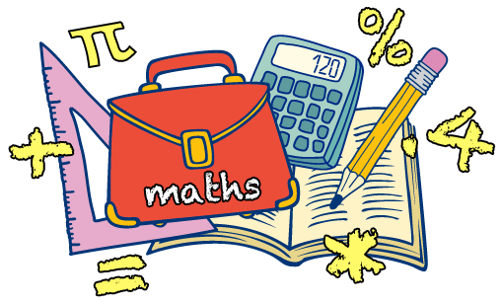

* We have been learning about ‘one more and one less’ in our Maths lessons.
* Make number cards. Choose a number, write it down. Add 1 and takeaway 1 from the number. Write the answers.
* Complete the worksheets in the Maths folder.
* Play this online game. <https://www.topmarks.co.uk/learning-to-count/chopper-squad>

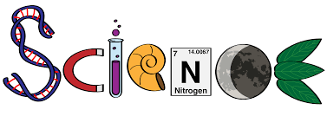

Plants

* This week we are going to learn about wild and garden plants. Use the search engine ‘Kiddle to find out more about them. You can find information in the Science folder.
* Draw or create a garden with wild and garden plants.
* Watch this video about plants. <https://www.bbc.co.uk/bitesize/topics/zpxnyrd/articles/zw2y34j>



**Geography:** This week make a leaflet about recycling. Listen to the story of ‘The Messy Magpie’ here: <https://www.youtube.com/watch?v=GvOhu2mLKsw>.

Watch these videos for more information.<https://www.youtube.com/watch?v=6jQ7y_qQYUA> <https://www.youtube.com/watch?v=7UuUeoyYmxI>

**RE:** Watch the videos on the links below.

<https://www.bbc.co.uk/bitesize/clips/z74wmp3> <https://www.youtube.com/watch?v=GWi7plHFJI8>

Create a mosque. It can be a sculpture or a picture. There is a mosque template in the RE folder.

**Computing**: Purple Mash: Use your log-in to explore all the games available. Explore 2Paint.

**Art:** Create some art using leaves. You can draw around leaves or use some paint to do some leaf printing. Try rotating the leaf to create a pattern. You can also try repeating a pattern.

**A time for us:** Do the quizin the A time for us folder. Discuss with your grown up what you have learnt.

Additional Activities/suggestions –You can email your completed work to ks1@northbeckton.ttlt.academy

Visit the ‘cosmic kids’ yoga’ page on you tube for some exciting yoga exercises or do PE with Joe Wickes on You tube.

The activity below is saved in this week’s folder.

* Do the 25 non-screen activities.